Class Work for 07 September 2024

List all hardware, telecommunication line, accessories and technologies

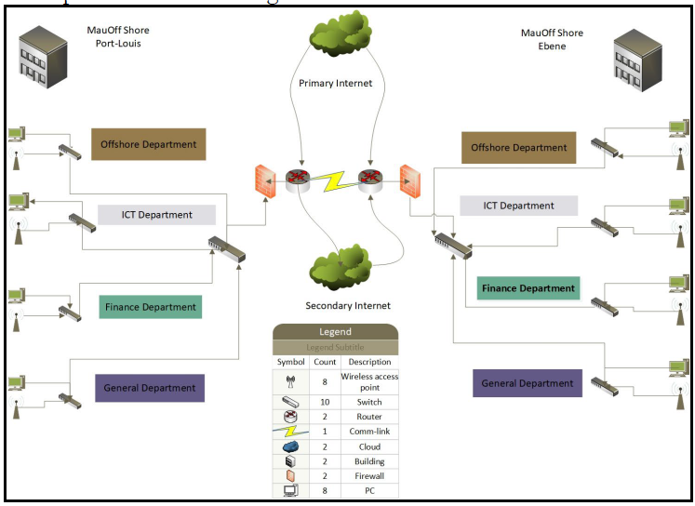

R.Bamma Class work 07 Sept 2024